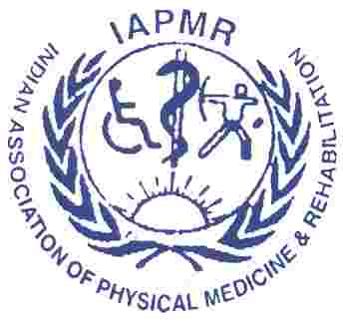 | DelhiPMRCon 2019  30 Nov-1st December 2019  14th Annual Conference of  Indraprastha Association of Rehabilitation Medicine  (ABVIMS & Dr RML Hospital, New Delhi) |  | 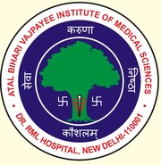
Registration Form

Name: …………………………………………………………………….………………….
Designation: ……………………………… Institution: ……………………………………………
Mailing Address: ……………………………………………………………………………………
Mobile: …………………… E-mail: …………………………………….…................................

Presentation: IPARM Gold Medal session: Yes/No
Last date for IPARM Gold Medal Abstract Submission: 1st November 2019
[Open only for IPARM member resident doctors (JR/SR)]
Email Abstract to Dr Deepak Kumar (deepdixit7200@gmail.com)
Delegate Category: IPARM Member: Yes/No

Registration fee: Rs 3000/- Only
Last date for Registration: 15th November 2019.
After that spot registration charges would apply: Rs 4000/-

I am enclosing herewith Cheque/NEFT ………… Dated ……… for Rs ….…… as registration fee drawn on bank ……….…………………… in favor of ‘Indraprastha Association of Rehabilitation Medicine’ payable at New Delhi.
NEFT: Punjab National Bank, Sarita Vihar Branch, New Delhi. A/c No.: 3976000100067179, IFSC Code: PUNB0397600.

Signature of the Delegate

Conference Secretariat:

Dr Shipra Chaudhary
Organizing Secretary DelhiPMRCon 2019
Room No 302, Dept of PMR, OPD Block, 3rd Floor
ABVIMS & Dr RML Hospital, New Delhi 110001.
Email: shipc76@gmail.com

